**Age and Gender Detection using Deep Convolutional Neural Networks**

**N VENKATRAMANA1,**

**G LAKSHMI PRIYA2, Y KALAVATHI3, Y PAVAN KALYAN4, P RAJASEKHAR5**

1,2,3,4,5Department of CSE,

1,2,3,4,5Annamacharya Institute of Technology & Sciences, Tirupati-517520

E-Mail: [venkatn.joshua@gmail.com](mailto:venkatn.joshua@gmail.com)

**Abstract**

Automatic prediction of age and gender from face images has drawn a lot of attention recently, due it is wide applications in various facial analysis problems. However, due to the large intra-class variation of face images, the existing models are still behind the desired accuracy level, which is necessary for the use of these models in real-world applications. Our model is trained on a popular face age and gender dataset, and achieved promising results. In this project, we are going to use Deep Learning framework, based on the ensemble of attentional and residual convolutional networks, to accurately identify the gender and age of a person from the image of a face. The predicted gender may be one of ‘Male’ and ‘female’ and the predicted age is in the range of (0 – 3), (4 – 7), (8 – 14), (15 – 24), (25 – 37), (38 – 47), (48 – 59), (60 – 100). Here we will use the Adience dataset.

**Keywords:** age classifier, predicted gender, age and gender dataset, attentional and residual convolutional networks, Audience dataset, facial analysis.

**Introduction**

Age and gender, two of the key facemask attributes, play a very initial role in social communications, making age and gender approximation from a single image an important task in intelligent applications, such as access control, human- computer interaction, law application, marketing intelligence and visual observation, etc. It can be used to suppose the age and gender of the user and use this information to make modified product and understanding for each user. It plays the vital role in marketing for the marketer by addressing the target audience on the basis of age and gender.

Age recognition plays a major role in Police investigation and Intelligence department as it is helpful in finding the actual suspect on the basis of his age. They could get a filtered-out result of that person who has performed criminal act or any other activity. If a person gives a biased opinion about his age after getting result from an age recognition software, then the actual age and predicted age would be approximately same. Which tells its reliability and this reliability make a trust factor for many other useful operations in daily life.

Speech and text vary from gender to gender and also with age. Prediction of Age and Gender still lacks its accuracy those move efficient way of predication is on the basis of face so that it can needs of commercial applications. Most of techniques presented in literature uses face recognition for prediction of age and gender but they use feature dimensions of face which is not as much efficient. Classification schemes are used for this purpose. Moreover, machine learning also didn’t exploit a large number of images and data from various sources through internet for improvement of classification activities.

In this paper we purpose a scheme to fill the gap between automatic face recognition and age and gender prediction. In the past when there is an improvement done on face recognition on large scale, at that point a link between face recognition and Convolution Neural Network (CNN) is proposed and by studying it further we created a system in which a limited amount of face data sets is used to accurately predict age and gender. A data of unfilled images is taken, despite of complexity we have in network design it performs well and gives a cutting-edge result. It provides a base to deep learning and suggests us that there is still a lot of room for improvements and the mysteries still remains unsolved. A data of pertained images is taken that are used to train model using HAAR Feature-based Cascade Classifiers.

Our objective is to make a system that would be efficient enough to predict age and gender of a person without breaching his security and other bypassing any other security. Such efficient systems are helpful in variety of ways in performing different activities. Our main objective is to train a model which can predict age and gender in most efficient way. It is also aimed to use in age specific content access limitation by which system can detect age and gender and allows/deny user to access that content.

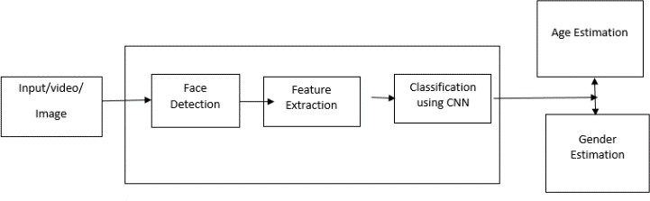

Fig 1: Age and Gender Model

The relevant applications of age and gender predictions systems are growing rapidly in recent days due its important modules and beneficial uses for computer vision application. There are some use cases that demonstrate the problem and we are going to address these problems.

Moreover, the best use of age and gender recognition is in social media, marketing and advertisements. Social media platforms can predict your age and genders and shows such contents which is of interest level of people of that age limit. It also helps growing e-commerce business and internet marketing business as it would help them advertise products according to interest level of that age group which in turn gives benefit to users too.

**Related Work**

The problem of automated age extracting attributes have been in attention for a long period of time. Early classification of age was done by calculation ration between different features of face like nose, eyes, mouth, chin etc. After localizing calculating their sizes and distances, ratio between them is calculated in order to predict age by using conventional methods. Recently a model is proposed to show age progression of people under 18 years old but that doesn’t work and pictures are different on social networks.

There are some other methods that predicts age as manifold but it requires well aligned and front facing images exactly, thus that proposition also don’t meets the needs. So, these methods give only experimental result on limited data sets. Thus, such methods are inappropriate to use in independent datasets. There is another method in which distribution of facial patches is discussed which is known is Gaussian Mixture Model (GMM). It is used for the representation of distribution of local facial measurements but is this instead of pixel matches, robust image matching algorithm is used. So, we cannot suggest it good model as we need to find out face patch distribution and for this Hidden-Markov-Model can be used.

Robust image descriptor technique is an alternate way for local image intensity patches. Gabor image descriptor method is used in used along with Fuzzy-LDA classifier to detect image of face belonging to more than one age group. As a whole Biological Inspired features (BIF) and other manifold-learning features are used for age prediction. Gabor image descriptor and local binary pattern (LBP) were used with hierarchical age classifier method consists of Support Vector Machines (SVM) are used to classify input image to a specific age class by using support vector regression so that the result obtained would be precise.

All of the above proposed models are used to have a precise age result by using different techniques and methods that are described in such models and performs a benchmark in age estimation. The best proposed model was implemented on a group photo having multiple faces in it. On this photo we implemented local binary pattern (LSB) descriptor and Support Vector Machine (SVM) classifier.

There is various method to classify gender. One of the methods of gender classification is by using neural networks trained on the small set of frontal faces image. It uses 3D structure of head and image intensities for classifying age.

Support vector machine (SVM) classifier were used and applied to image intensities. In spite of using SVM, we can use Ada boost which is a replacement of SVM having same functionalities. In the recent, Weber’s Local texture descriptor is used which gives a perfect result on Face Recognition Technology (FERET). In this concentration, form and quality structures used to predict the most perfect and accurate result on FERET benchmark. Most of the methods described above uses FERET benchmark to develop a most precise system giving accurate results. FERET images were taken to extremely measured complaint and the result obtained from them are highly saturated. It is actually difficult to find out actual advantages of these techniques. Face recognition is also used on Labelled faces in the wild (LFW) and this method has a combination of Local binary pattern (LBP) and an Ada boost classifier.

In the past when computers were not efficient then it was a great job to make computer perform tasks as the interaction of people vary to each computer. Every person cannot respond to computer in similar way. There was need of making Human Computer Interaction (HCI) easy so that it would be accessible for everybody. But now due to age predictor computer can understand how to respond to a person of that age.

Thus, the methods presented above, we have noticed that we used dataset which is more difficult and challenging them images used in Labelled faces in the wild (LFW) and gives more accurate results in robust system and gets more information form massive data set.

**Methodology**

The first application of Convolutional Neural Network (CNN) is LeNet-5 network by using optical character recognition. If we compare this activity with modern deep convolutional network technique it is considered to be very simple and humble as that time there were limited computational resources and there are challenges to train algorithms.

Now the time has come when neural networks become so deep that they became prevalent due to increase in computational resources and the training data is easily available on internet. Moreover, now such methods are available that can train data easily and readily. Now there are various application of Convolutional Neural Network (CNN) are present like human pose estimation, face parsing, facial key point detection, and speech recognition and action Classification. On unconstraint photo this is their first application according to our knowledge.

We have noticed that if we want to gather large datasets of images from social platform them it may require their privacy permission or may become a security hazard and its very time taking to label is manually. Dataset from real world social images we have noticed that they are limited in size and they have no match in size with larges database image sets. Over fitting is a common problem while using machine learning based methods on small image collections. This problem is intensified when considering deep convolutional neural networks due to large parameters. So, we have to be very careful while using such methods.

The system we proposed works perfectly fine with experiments in classification for age and gender. Our networks consist of three convolutional layers in which two of them are fully connected with small number of neurons. We use small network design for taking less risk for over fitting and also for the nature of problem we are going to solve. Classification of age on dataset requires to differentiate between eight classes and for two genders. Thus, we can say that ten thousand classes are used to train the datasets used for face recognition.

The retail store owner needs the analytics of his store. He wants to find the number of visitors by age group and genders. He also wants to find the most popular aisles and the articles viewed by age group. The system needs in smoking areas for age detection to stop the growth of teenage smokers. The smoking areas should ahead the cameras to identify the age group of the smokers.

TABLE 1. AGE AND GENDER CLASSES

**Experimental Work**

We trained our technique on the as of late proposed informational index of countenances for age and sex order. The data-set of countenances contains naturally transferred Flickr pictures. As the pictures were naturally transferred without earlier sifting, they portray Testing in-the-wild settings and differ in outward appearance, head present, impediments, lighting conditions, picture quality and so on. Additionally, a portion of the pictures are of exceptionally low quality or contain extraordinary movement obscure.

|  |  |  |  |  |  |  |
| --- | --- | --- | --- | --- | --- | --- |
| **Age and** | 15- | 25-32 | 38-43 | 48- | 60+ | Total |
| **Gender** | 20 | 53 |
| **Group** |  |  |
| **Male** | 734 | 2308 | 1294 | 392 | 442 | 8192 |
| **Female** | 919 | 2589 | 1056 | 433 | 427 | 9411 |

The figure above (first figure in the post) illustrates example images from the dataset of Faces. Below is a breakdown of the dataset into the different age and gender classes. A number of other prediction models are proposed in literature and can be found in.

1. Initialization

The weight in all the layers is initialized with random values to zero which means Gaussian with standard deviation of 0.01. We do not use models that are already trained but we trained them from scratch without using any outside labelled datasets

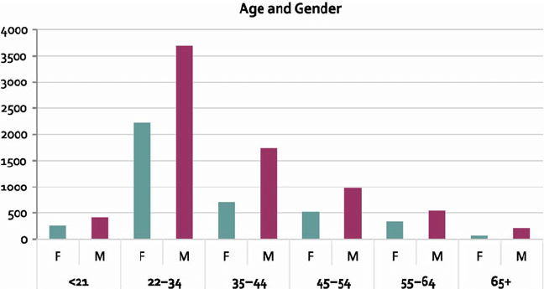

**Architecture of CNN**

Five network architecture layers are used in this model. Two of them are fully connected layers and three convolutional layers are used.

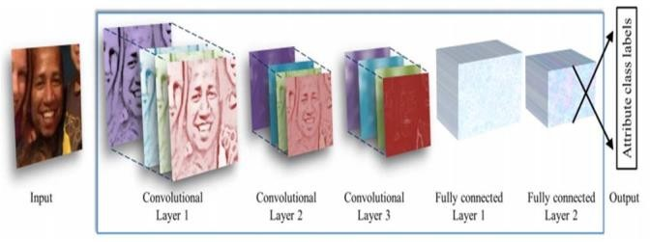

Fig 2: Architecture of used CNN

**Results and Evaluations**

We tried different things with two techniques for characterization:

• Centre Crop: Feeding the system with the face picture trimmed to 227 × 227 around the face focus.

• Over-testing: We separate five 227 × 227-pixel crop locales, four from the edges of the 256 × 256 face picture and one from the focal point of the face alongside their flat flips [23]. Each of the 10 yields are encouraged to the system and the last order is the normal of the forecasts of the 10 crops.

The tables below summarize our results compared to previously proposed methods.

|  |  |  |
| --- | --- | --- |
| **Method** | **Exact** | **1-off** |
| Best [28] | 45.1 ± 2.6 | 79.5 ±1.4 |
| Proposed by single produce | 49.5 ± 4.4 | 84.6 ± 1.7 |
| **Proposed by over-sampling** | **50.7 ± 5.1** | **84.7 ± 2.2** |

TABLE 2. Gender Predication

We measure mean exactness + standard variety, 1-off in age arrangement implies the age expectation was either right or 1-off from the right age class.

|  |  |
| --- | --- |
| **Method** | **Accuracy** |
| Best [2] | 77.8 ± 1.3 |
| Best [29] | 79.3 ± 0.0 |
| Proposed by single produce | 85.9 ± 1.4 |
| Proposed by over-sampling | 86.8 ± 1.4 |

TABLE 3. AGE PREDICATION

**Conclusion**

Human Age and gender classification” are two of the many valuable information gathering resource from and individual. Human faces provide enough data which may be used for many purposes. To reach the correct audience human age and gender classification is very essential.

Human Age and gender classification” are two of the many valuable information gathering resource from and individual. Human faces provide enough data which may be used for many purposes. To reach the correct audience human age and gender classification is very essential.

The task of recognizing age and gender, nonetheless, is an innately troublesome issue, more so than numerous other PC vision undertakings. The fundamental justification for this trouble hole lies in the information needed to prepare these kinds of frameworks. While general article discovery errands can regularly approach many thousands or even large numbers of pictures for preparing, datasets with age and gender names are extensively more modest, as a rule in the large numbers or, best case scenario, several thousand.

**References**

[1] A. A. Zaidan, B. B. Zaidan, A. Al-Haiqi, M. L. M. Kiah,

M. Hussain, and M. Abdulnabi, “Evaluation and selection of open-source EMR software packages based on integrated AHP and TOPSIS,” J. Biomed. Inform., vol. 53, pp. 390–404, 2015.

[2] T. Ahonen, A. Hadid, and M. Pietikainen, “Face description with local binary patterns: Application to face recognition,” IEEE Trans. Pattern Anal. Mach. Intell., no. 12, pp. 2037–2041, 2006.

[3] R. Sharma, T. S. Ashwin, and R. M. R. Guddeti, “A Novel Real-Time Face Detection System Using Modified Affine Transformation and Haar Cascades,” in Recent Findings in Intelligent